# **Understanding**

Task1- Mechanic Login

1. Rename the Button:- Change the button label from "Agregar Trabajo" to "Lista de Mecanicos Mobiles" in your code.

2- Display the List of Mechanics:- Implement or verify that the functionality to display the database of mechanic names is correctly linked to the button. This might involve querying the database and rendering the results in the UI.

Spreadsheet fields –Fields should be same as registration form showing except password username and email field for reference checklist of Mechanics button showing spreadsheet under the trucker profile. The format and UI of the list should be same as its showing for other list under the trucker login. Also arrange fields in same sequence as its showing for registration

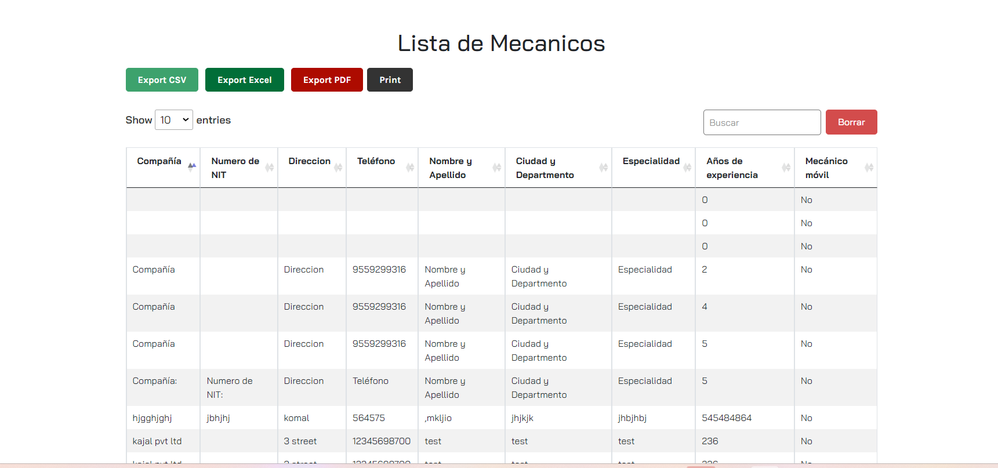

3-Restrict Deletion Permissions:- Make sure that the displayed list of mechanics does not include any options or functionalities that would allow users to remove or modify listings.

Task 2**- Restaurant Login**

**Button Placement:**

* **Location:** Add the button below the section marked with a red box.
* **Label:** The button should be labeled "Restaurantes Participantes."
* 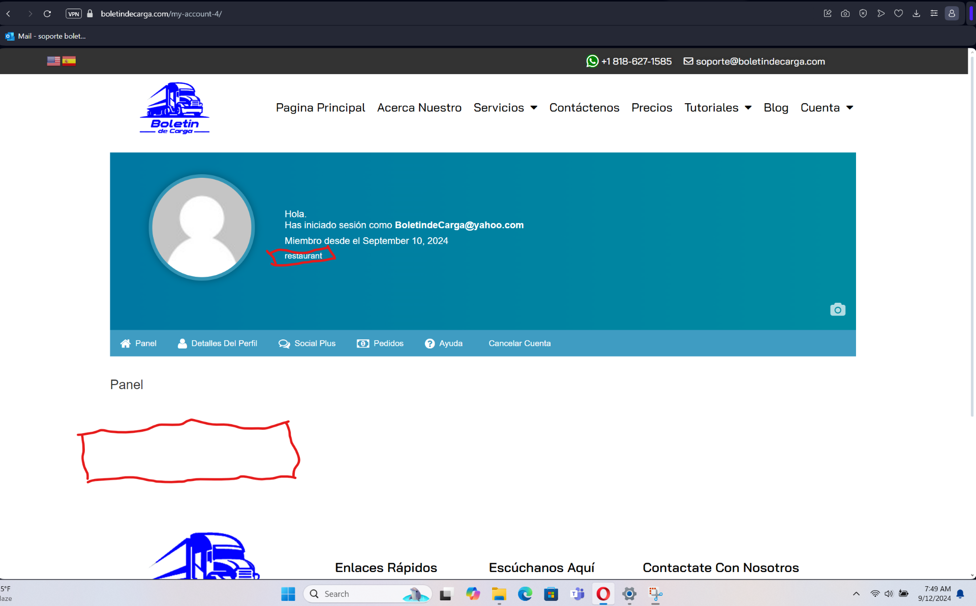

**Button Functionality:** 1-Upon clicking the button, the application should display a spreadsheet or table that lists all the restaurants.

2-Users should be able to view the spreadsheet but should not have the capability to delete or modify any of the restaurant listings.

Spreadsheet fields –Fields should be same as registration form showing except password username and email field for reference checklist of Restaurant showing spreadsheet under the trucker profile . the format and UI of the list should be same as its showing for other list under the trucker login . Also arrange fields in same sequence as its showing for registration .like this - 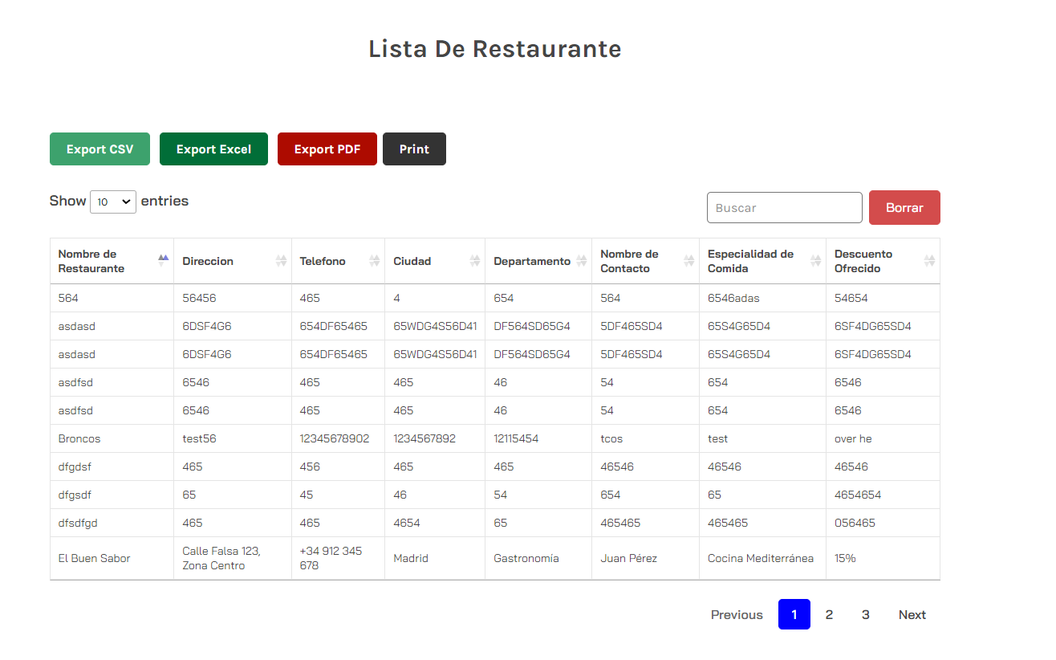

**Task3- Insurance and Abogados Participantes profile pages**—Show same functionality for insuransce and Abogados Participantes profiles as we are showing for resturent login like this

Insurance -

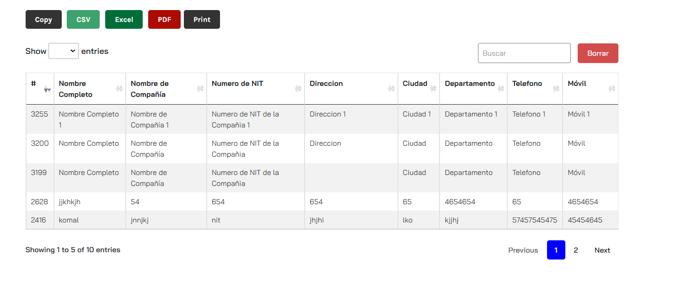

Lawyers- 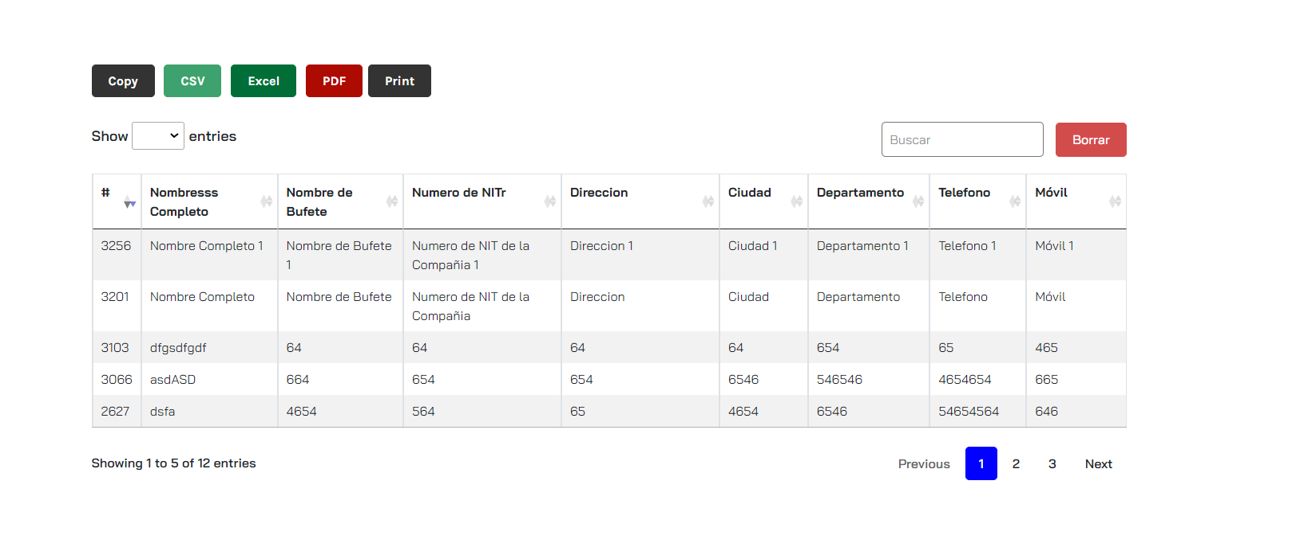

Note – For all tasks all fields of the list should be same as its showing for the registration for the users .